CHAPTER 2

LITERATURE REVIEW

2.1 Techno-Economic Assessment of PV–Battery Systems
The representation of critical technological pathways for advancing renewable energy utilization and grid independence links directly to the integration of photovoltaic (PV) systems with battery energy storage systems (BESS). This will be a deep study on the techno-economic assessment of PV-BESS in relation to different aspects, starting from the economic foundations, simple evaluations, methodologies, empirical evidence, and concluding with recent gaps in research.

2.1.1 Fundamentals of PV and Battery System Economics
The viable economic value of a joint system of photovoltaic (PV) and battery energy storage (BESS) depends entirely on its delivery of net financial benefits with realistic conditions of operating life, technical degradation and market. The profitability of PV-BESS simply reflects a lifecycle cost-benefit balance where financial costs and initial cost of investments are compared to the extended savings of elevated self-consumption, shifting in load and limited dependence or reliance on the grid. [1]
Credible assessment must incorporate lifetime and replacement effects due to the outcomes realized over many years. Several elements such as batteries and power converters which are very critical can require replacement within the projected horizon, and ignoring these replacement cash flows can eventually skew the return-on-investment estimates [2]. It is important to understand that, the powerful economic drivers in this case can be identified as follows:
- The gap between retailed price of electricity and export remuneration
- The investment cost of battery systems
- Useful battery capacity
These factors signify that positive returns are strongly scenario-dependent rather than generic [3].
Furthermore, it remains inherently uncertain that evaluation of PV–BESS is due to essential inputs, including interest rates, future electricity prices, and demand patterns which cannot be precisely projected. Behavioral changes in consumption can elevate or erode independence and therefore change the outcome of profitability over the system lifespan [4].
It is important to note that the result strongly depends on uncertainty in assumptions; there must be several tests in scenarios to see if the conclusion remains reliable

2.1.2 Economic Metrics for Energy System Evaluation
Techno-economic evaluation of both PV and PV–BESS investments rationally depend on a minimal set of metrics that treats long-established costs and savings as indicators that can be compared. The selection and use of appropriate economic metrics are essential for precise decision-making.
Net Present Value (NPV) and Related Indicators
Investment evaluation is a central point to the metric Net Present Value (NPV), which is a discount of all future net cash flows over a project's lifetime. It provides a comprehensive measure of profitability. Two other metrics, known as Internal Rate of Return (IRR) and payback time, act both as complements to NPV, ensuring a standard threshold for investment irrespective of different electricity prices, system yields, and costs [5]. It is well known to report NPV along with simple and discounted payback periods (and sometimes complementary indices) to show both profitability and the time required to recover capital in a manner that is interpretable for both planners and households [6].
Levelized Cost of Energy (LCOE) and Its Variants
Levelized Cost of Energy (LCOE) provides a cost-per-unit form that facilitates comparing distinguished technologies over time. However, there is a standard caution that LCOE can underrepresent the influence of finance. Modified levelized metrics, which could either be the Modified Levelized Cost of Energy (MLOCE) and Modified Levelized Avoidable Cost of Energy (MLACE), incorporate explicitly parameters like rate of discount and loan/payback structure, which could better reflect the financial and production relationship that drives feasibility for renewables [7].
At the system level, considering higher shares of variable renewables, LCOE comparisons may not be complete as they omit integration impacts. There is an extension of the LCOE, like the marginal integration costs (notably profile-related costs), which gives a more realistic measure of competitiveness as we see an increase in renewable penetration.[8].
Uncertainty-Aware Metric Formulations
The outcomes of PV(–BESS) depend on uncertain prices and cash flows; there are uncertainty-aware formulations that can produce varying decisions. Comparing the stochastic NPV and stochastic LCOE approaches could potentially lead to related conclusions in some instances but may diverge under an exposure-focused orientation, reinforcing the need to tailor the metric to the decisive context and risk treatment [9]. For residential and community-scale investments, this consideration is specifically important where risk tolerance may differ significantly from utility-scale projects.

2.1.3 Empirical Studies on PV–BESS Techno-Economic Performance
Significant variability in economic performance across different contexts is revealed due to the empirical evidence from operational and simulated PV–BESS systems, which indicates the need for site-specific factors and system design choices.
Capacity Factor and Load Alignment
Considering a rooftop PV-BESS system, the profitability could potentially be lost even in favorable policy conditions. The viability of the economy depends significantly on the alignment of both the utilization and the load generation. Profitability comes strongly when the PV-BESS operates sufficiently at high-capacity factors (reported as ≥18%), while the elevated consumption of electricity during the day could potentially lead to savings with smaller storage capacities. Limitedly provisioned systems and prosumers with low occurrence of generation and demand often lead to specific subsidy allocations to attain profitability, masking the deployment outcomes of irregularity across multiple households [10].
Real-World Performance Under Variable Tariffs
Monitored performance under distinguished tariffs strengthens the necessity of temporal alignment. A study reflecting a 5-minute operational data taking the time-of-use (TOU) tariffs shows a large variation in season (lower in winter, higher in summer). This study reveals that dispatch of battery for high-tariff periods could eventually minimize the yearly cost of electricity, with the joint PV-BESS system performing so much better than both PV-only and grid-only configurations and receiving the payback of available financial support at the shortest time [11].
However, the same study indicates constraints in infrastructures, which include the instability of the grid voltage and shutdowns of inverters, especially at high PV generation, can limit realized value and should be taken into account [11].
Storage Addition and System Optimization
For extended comparison, increasing self-consumption and enabling strategic shifting could come from additional storage, which often improves the profitability of households. This naturally raises NPV and reduces payback. Storage does not result in a reduction in the metrics of unit cost because there is a compilation of both capital cost and losses by conversion on batteries. In this form, LCOE can increase even if there is a general improvement in profitability, depending on specified objectives [12].
There is justification that economics is strictly coupled to the context of design and tariff. Optimized sizing (treating the power and energy of the battery as decision variables) can minimize total costs, unlike the static sizing that tends to oversize the battery. The preferred viable battery is consistently smaller and widely used, specifically when the spread of tariffs is restricted, and remuneration export is present. This shows the central trade-off between maximizing economic performance and self-consumption. [13].
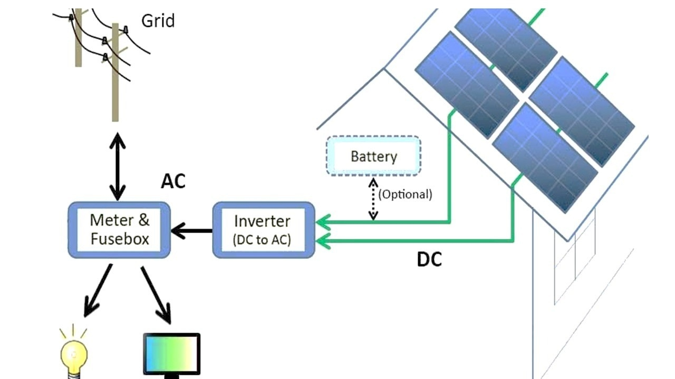
2.1.4 Key Findings and Research Gaps
Assumptions like flat-rate tariffs, sufficient rooftops, and dependence on annual averages in the long-term, instead of time-resolved optimization, could cause limitations in reality [10]. Fixed dispatch necessity and reduced control flexibility can accurately prevent replication of real operation, concerns of comparability, and leave the conditions under which batteries maximize NPV and payback benefits across configurations and tariffs unresolved. [12]. Subsidy structure that separates storage could potentially soften the business case of storage even when the cost falls, while longer-term effects on differentiation in price and choices in size configuration remain not sufficiently tested across multiple scenarios [14]. There are other persistent limitations relating to PV–BESS-specific studies which include empirical evidence, Consistency in Methodology, Socio-institutional coverage [15, 16]. Environmental impacts and pathways of recycling, considerations of power quality, and optimal sizing and integration in multiple storage technologies remain unresolved [15]. Opportunities like algorithm dispatch for load shifting, variable sub-hours, costs of replacement, and the desire to upgrade real-time controls are significant approaches to consider [16].

2.2 Value Streams of Battery Energy Storage
Multiple value streams are provided by battery energy storage systems (BESS), which contribute to both benefits from private economy and public grid services. Examination of the principal value streams in relevance to residential and community-sized applications, quantifying battery-specific contributions and identifying gaps, in the assessment and attribution of this value stream.

2.2.1 Energy Arbitrage and Price-Spread Exploitation
In the context of electricity markets, energy arbitrage involves the methodological purchase and selling of energy to capitalize on the discrepancy in price [17]. This involves buying energy from the grid when prices are low and selling it back to the grid when prices are high, which is a typical practice [18]. Taking advantage of the electricity price differences by having electricity stored during low-price periods and releasing it during periods of high price is what arbitrage of price is focused on [19].
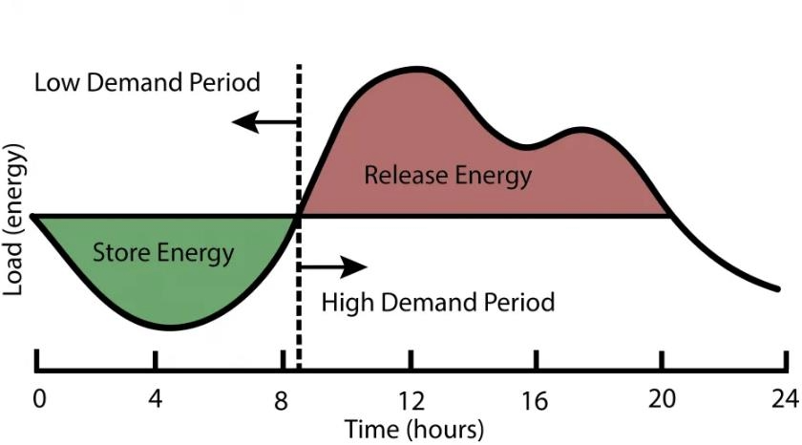
Market Efficiency and Grid Stability Benefits
In promoting market efficiency and enhancing stability in the grid, energy arbitrage plays an important role. Exploiting differentials in price across distinguished periods in time or geographical location, it helps balance the dynamics of supply and demand, contributing to the general stability of the grid [17]. Some of these significant benefits include:
- Market Efficiency and Stability: Arbitrage supports the reduction in price fluctuations, which allows the presence of a more stable and predictable energy market for both consumers and producers involved.
- Investment Attraction: The potential profit from energy arbitrage can motivate investments, specifically in renewable energy systems (RES) and storage technologies, thereby facilitating the transition towards a sustainable energy future.
- Competition and Innovation: Arbitrage can enable competition among suppliers of energy, pushing innovation and encouraging the adoption of energy generation technologies that are more efficient and environmentally friendly [17].
Profitability and Market Variability
There is a huge significance to the profitability of energy arbitrage, especially when enabled or supported by battery energy storage systems (BESS) [17]. However, on specific market conditions and regulatory frameworks, this profitability is dependent on multiple countries [17]. The overall revenue derived from energy arbitrage is defined by the power discharged and the corresponding cleared price [18]. Energy arbitrage value is linked to the characteristics of the respective energy market [18].
The benefits of arbitrage within European markets have been seen [18], though the potential for energy arbitrage across different jurisdictions varies [18]. In Ontario, for instance, the activity of energy arbitrage is naturally “behind the meter” [18]. There could be a significant difference in energy arbitrage profitability by as much as ±25 % between years in most major electricity markets. This presents a risk in finance to investors unless hedged, as instability can lead to reduced access to borrowing at low-cost.[20].
Factors Influencing Arbitrage Value
The arbitrage value is impacted by efficiency, storage capacity, transmission constraints, and fuel mix [18]. The economics of this arbitrage could influence the improvement in battery technology [21]. Consistently, these factors contribute to the realized value in any given market context.
Modeling Approaches
To study and optimize energy arbitrage, various models have been developed. There are uncertainties of energy prices that have been considered by several models [18]. For energy arbitrage profit maximization, a day-ahead stochastic formulation for energy has been proposed and has shown good performance by implementing realistic energy price data [18]. For BESS arbitrage, another stochastic model considers different ranges of prices, battery lifetime, and indices of performance [18]. Basic studies have investigated the value of energy arbitrage in multiple locations, sometimes without taking into account the optimal sizing of BESS [18]. Comparisons between different markets help present in each market the potential of energy arbitrage [18].

2.2.2 Self-Consumption Enhancement in PV Systems
A significant value stream for residential and commercial PV–BESS systems is self-consumption. This is represented especially in regulatory forms where there is a limitation on remuneration export or a substantial spread of retail-export price.
Self-consumption in photovoltaic (PV) systems is known to be the custom of absorbing locally a fraction of the solar energy produced, instead of exporting the energy to the grid [24, 25]. For households with PV systems, this practice is important, as a useful approach to elevate PV self-consumption, which is prominently being sought after [22]. To increase the economic profitability of PV systems, owners of buildings often view self-consumption as a means to do just that [23].
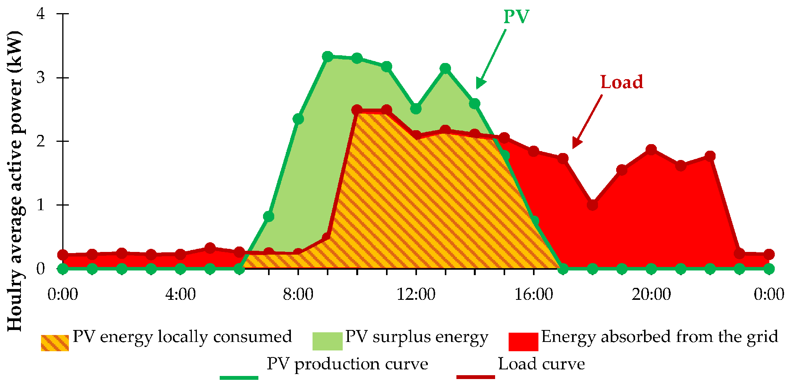
Economic Benefits
The economic return of PV can be increased through self-consumption by permitting the direct use of generated energy in local regions. This allows avoiding the elevated cost of importing electricity from the grid as well as exporting it at a lower price [24]. This becomes extremely important with minimized export-based incentives for systems tied to the grid [24]. The export of energy generated by PV at a premium level is difficult, so the storage of excess production becomes cost-effective, especially with the decrease in the price of batteries [24].
Grid and Environmental Benefits
Self-consumption supports stress reduction on the distribution grid [24, 25, 27]. By utilizing energy from PV locally, it simplifies variations in production from solar power and prevents transport losses, thereby enhancing the efficiency overall of these systems [24, 27]. This can potentially also increase the capacity of the grid to allow renewables by inserting energy storage and load shifting that are battery-based [24]. There can be a reduction in CO₂ emissions, which could be contributed to by enhanced self-consumption [25].
There may be a reduction in governmental financial support for PV generation for self-consuming technology, which is visualized as a way to ensure the continued financial practicality of the PV industry [24].
Methods for Enhancing Self-Consumption
Battery Storage Integration
A highly effective method for improving self-consumption is through battery storage. By an estimate of 13–24% incorporating a battery system sized 0.5–1 kWh per kW of PV, there can be provision of increased self-consumption [24]. There have been studies that reflect elevated increases, with a conclusion that there could be a rise of about 82% with specific battery configurations, in contrast to systems with no batteries [24].
The systems of energy storage are usually not installed with PV systems in residential areas, which is because of the presence of “too much” unharvested solar energy. The key to improving self-consumption and self-sufficiency is the integration of storage [22]. However, to avoid oversizing, the PV system or battery without considering economic viability, caution must be taken into account [24].
Load Shifting
Self-consumption can increase by 2–15% from load shifting [24], providing a strategy that is complementary to battery storage for improving utilization of PV.
Design and Optimization Research
Approaches have been explored for systems designed to improve PV self-consumption [22]. This includes investigating building size influence, consumption patterns, and the PV panels façade integration [23]. Opportunity to increase PV electricity self-consumption using residential house data has become prominent in recent years [26]. PV self-consumption has been potentially modeled across multiple types of buildings and countries across Europe [24]. This allows extended research of PV used on-site while minimizing the electricity that is required from the grid, thereby sustaining imports and exports of energy into the grid [24].

2.2.3 Peak Shaving and Load Shifting
For commercial and industrial consumers which faces demand charges and for operators in the grid who manage system peaks, peak shaving, and load shifting reflect important value streams for battery energy storage.
Definition and Objectives
This is known to be a strategy employed in the energy industry to adjust load peaks and minimize associated peaks in grid consumption, specifically for industrial and commercial uses [27]. This method is essential not only for maintaining the stability of the grid but also for managing the cost of electricity [27]. The reason peak shaving is necessary is to reduce the highest demand peaks from the grid. This could often be done by using a battery or flexible loads.
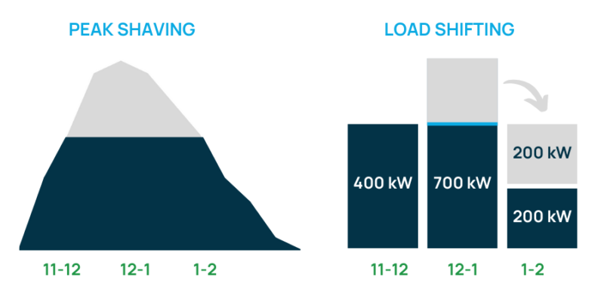

Benefits for Grid and Consumers
There are multiple advantages to peak shaving for both grid operators and consumers:
Grid-Level Benefits
- Due to heavily stressed loads from short-term, it provides stability in the electricity grid [27]
- Support the prevention of instability, sudden blackouts, and fluctuations in voltage, which improves power quality [28]
- Congestion of transmission lines is significantly reduced [29]
Consumer-Level Benefits
- The electricity costs will be significantly reduced by lowering the energy and power components of the electricity bill [29]
- Peak demand charges are significantly reduced [29]
- Provision of good power quality [28]
Environmental Benefits
Carbon emissions can also be reduced, from peak shaving with Battery Storage Systems (BSS), which permits power plants to operate more efficiently with a minimized variability in load [28].
Implementation Methods and Technologies
To achieve peak shaving, several methods and technologies are utilized:
Battery-Based Approaches
Electric vehicles (EVs) and batteries, including stationary battery systems, are commonly used to minimize peak demand [27]. A well-prominent method involves deploying solar photovoltaic (PV) and battery energy storage (BES) systems that are connected to the grid [28]. When a set limit is exceeded by the load demand, there is an activation of the peak shaving mechanism, reducing the power supplied to the load and elevating the power from the battery storage. [28] Furthermore, there is a display of the State of Charge (SOC) of the BSS as the battery reservoir in terms of percentage [28].
The mid-scale systems, BSS, are considered a very effective peak shaving process, though it demands a computational mechanism for scheduling and sizing [28].
Demand Response Integration
Demand Response (DR) measures can also be used for peak shaving [29], which provides benefits such as minimizing load during peak periods and reducing fluctuation of wholesale prices [29].
Operational Characteristics
The objective is for peak shaving strategies to achieve the flattest possible daily power diagram [29]. Based on the behavior of the load profile after peak shaving, the grid voltages fluctuate. When there is a decrease in the power supplied to the load, this causes a decrease in the voltage as well, and vice versa [28]. Increase with the inclusion of Electric Vehicles, stationary battery storage, and a PV system is highly possible due to peak shaving and the correlated reduction in the capacity cost from the grid [27].

2.2.4 Methods for Quantifying Battery-Specific Contribution
Establishing metrics of the battery energy storage contribution within this system (PV-BESS) is very important for both economic assessment and decision-making in investment. Evaluation of the methodologies for isolating battery value from the entire system benefits.
Conceptual Framework
Quantifying battery-specific contribution deals with methods to separate the benefits of the finances or operation that are directly linked to the battery energy storage system (BESS). This makes it different from the actual value or benefits obtained from the components, such as solar photovoltaic (PV) systems, or from a no distributed energy resources (DERs) baseline [30]. This separation provides a clear comprehension of the battery’s supplemental value when it is inserted into a system, especially with the consistent rise in penetration of PV systems with batteries [30].
Measuring the progressive value that a battery brings is a unique perspective to take into account. Quantifying the entire system’s performance upgrade or cost savings is due to the operation of the battery instead of just the PV system or the electricity grid [31]. Frequent capture of the true value of multiple services occurs when they are stacked and given value. [32].
Methodological Approaches
To quantify the battery’s unique contribution, there are three main bodies of approach:
1. Comparable Baselines
Different baselines establish comparable scenarios, and to isolate the battery’s impact, we compare outcomes [31]:
- No-DER: This is a baseline with no PV or battery system involved
- PV-only: This is a system with PV but without battery storage
- PV–BESS: Integrated system of both PV and battery storage
The value of the battery is typically calculated as the difference between the outcome of the PV–BESS and the PV-only system [31]. This form ensures a clear attribution of a systemic increase in the value of storage.
2. Incremental Metrics
The added value of the battery from metrics quantifies by directly comparing performance with and without the battery in the system. These metrics provide support to determine if there can be justification of costs for more revenues and savings from BESS [33]. Some of these growing metrics include:
- ΔNPV = NPV(PV–BESS) − NPV(PV-only): This measures progressive net present value
- Δannual bill = Bill (PV-only) – Bill (PV–BESS): This quantifies annual cost savings
- ΔSCR = SCR(PV–BESS) − SCR(PV-only): This capture change in the ratio self-consumption
Residential batteries maximizing PV self-consumption often provide almost no value to the grid. There is a presence of ‘value gap’ as a result of discharge constraints and batteries being inactive during peak days [31].
3. Attribution Approaches
Attribution mechanisms are used to distribute value fairly when a BESS provides many services that are compatible and are both stacked and valued [32]. These include:
- Scenario subtraction / marginal analysis: This is a steady elimination of services to separate different contributions
- Shapley value: A game theory approach that is cooperative, principally used for allocating benefits instead of operational dispatching
These techniques are significant for ensuring an economic case for the storage of energy, specifically given that previous difficulties are due to the absence of agreement on how to model the services they provide [34].

2.2.5 Other Value Streams in Literature and Scope Exclusions
Battery energy storage systems (BESS) provide multiple value streams exceeding simple arbitrage, self-consumption, or peak shaving. These increased services contribute to the stability of the grid, reliability, and efficiency of the economy. They mostly introduce complexities that resulted in their exclusion from unique scopes.
Ancillary Services
Under the umbrella of ancillary services, multiple key value streams were discussed [39, 40]. Ancillary services are known as services required by either Transmission System Operators (TSOs) or Distribution System Operators (DSOs). This enabled integrity and stability maintenance of the transmission or distribution systems, and even the quality of power [35]. These services can be grouped into:
Short-term services: - This involves voltage control and frequency regulation
Long-term services: - These are congestion management, peak shaving, and power smoothing [36]
Applications of Specific Ancillary Service
Frequency Regulation
The participation of ancillary services can produce substantial revenues, with the most important ancillary service markets often including regulation in frequency [37]. Frequency regulation means establishing a grid frequency bounded by true limits by constantly injecting or receiving power. This enables earning revenue for both reservation capacity and dispatch performance. Service for frequency regulation can receive multiple dispatch calls daily in the hundreds [37].
Voltage Regulation
Voltage regulation means providing support to grid voltage stability, which often happens through reactive power fixation or absorption [39, 40].
Congestion Management
Congestion management requires the relief of grid bottlenecks during periods of high generation or low demand, saving energy and releasing it during periods where the demand is high, or the transmission grid is constrained [36].
Resilience and Backup Power
Backup power is very important in the concept of BESS transitioning out of a moderate state to give an alternative during service failure of utilities [38].
Scope Exclusions and Rationale
There are multiple complexities associated with modeling ancillary service markets and instant dispatch. Power flow, constraints on the network, and valuation of probabilistic outage are all some of these complexities, but are excluded to retain focus on the scope and main economic benefits [41, 42].

2.2.6 Key Findings and Research Gaps
The addition of value by battery storage to PV systems is done mainly by raising the self-consumption of solar energy. Minimizing the electricity export from the grid, reducing peak demands, and allowing minimal energy arbitrage are other ways to add more value. The economic benefit attributed to this value is due to either the methods of pricing, restriction of the grid, limits in the inverter, or operational constraints. There is no isolation to a battery’s increasing value from a PV system. Tariffs and other settlement mechanisms depend on the dispatch assumptions that may not show the exact operation, and results are reported in ways that prevent comparison across multiple studies.

2.3 Co-Located PV and Battery Systems in Energy Communities
A joint system of photovoltaic (PV) and battery energy storage systems (BESS) situated within energy communities reflects a unique pattern for maximum utilisation of renewable energy. This allows for the reduction in grid dependency and the achievement of energy management that is much more cost-effective at the community scale. The technical advantages have been well studied for the co-located PV–BESS configurations, which provide reviews of observational evidence from large-scale deployments. The analysis of sizing and operational strategies signifies the main gaps in research that persist in multiple studies.
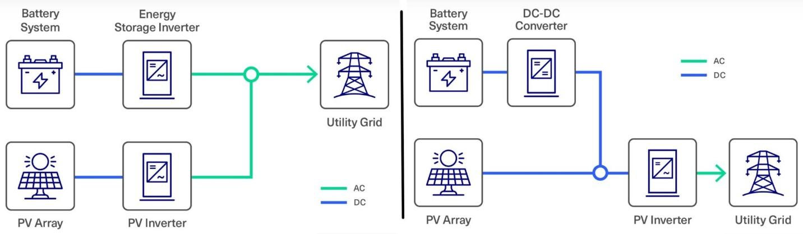

2.3.1 Technical Advantages of Co-Located PV–BESS
The provision of multiple technical advantages, improved operational efficiency, reliability, and renewable energy installation stability is achievable by a joint system of photovoltaic (PV) systems with battery energy storage systems (BESS). This integration supports energy management, elevates the flexibility of systems, and improves the stability of the grid.
Integrating BESS provides increased production and makes the operation of PV systems more efficient [40]. It also helps improve energy continuity in general [40]. Having a co-located system ensures the power supply is uninterrupted [40]. The rate of using PV improves significantly with the support of BESS, which reached up to 92% compared to 63% without it. This ensures renewable energy self-consumption and load shifting to be better [40].
A combined system of PV and BESS provides enhancement in usability [40]. These enhanced PV systems offer a useful understanding for optimizing system design, management, and strategies for control [40]. Integrating BESS supports the balance of grid frequency [40], and in terms of efficiency and grid stability, for the PV system, this ensures significant gains [40]. A hybrid PV–BESS system can reduce the requirements of the external power grid and provide enormous performance in operation to DC microgrids [40]. It is also good to understand that with grid-forming control under various conditions, BESS shows significant reliability [40].
The integration of BESS can elevate the production of energy. An illustration shown by a scenario shows there is an increase of 153.2 MWh compared to a system without BESS [40]. This could also allow for a 4.8% increase in the performance ratio (PR) [40]. Such systems can result in a decline in peak load (e.g., 32.7%) and minimized usage of grid energy (e.g., by 50%) [40]. While co-locating PV and BESS systems provides substantial technical benefits, their economic favorability and the benefits scale could be due to factors such as the use, size of PV system, enhanced control equipment, structure of customer rate, and cost of operations [40].

2.3.2 Empirical Studies on Community-Scale PV–BESS Systems
In energy management and cost reduction, community-scale PV and BESS systems are increasingly being explored for their potential benefits. This involves the sharing of PV and energy storage systems with different users within a specific community [41][42]. The main objective of many studies is to reduce the overall costs for energy, which can be effectively done by making use of energy from the community’s PV system and managing the Storage System [41]. In addition, BESS are known to be remarkable options to elevate self-consumption of energy that is produced locally from PV systems [43]. A community-based District Battery Energy Storage Systems (DBESS) can significantly improve the independence and self-consumption of PV systems in either rural or urban communities compared to a single person’s home battery system [44]. Studies also justify that the strategies of maximum energy management, which include getting involved in ancillary service markets, could significantly limit the established levelized cost of energy (LCOE). It is important to note that communities where PV and BESS overall costs are decreased fairly could potentially benefit the overall community [45]. In general, optimal planning and scheduling of BESS can enhance self-consumption and reduce costs. Different approaches that allow financial risks to be minimized can be done by applying stochastic programming and real data from photovoltaic systems, as well as large differences in load profiles within a community [41].
Multi-objective optimization coupled with frameworks like Monte Carlo is often employed to deduce the consequence of varying PV capacity on costs and size of ESS. This allows the minimization of the total costs while sizing the ESS and checking the PV contribution if it is fixed or variable [41]. Different types of users in energy communities with shared PV and ESS systems can use the variability of their load profiles in multiple applications. Some of these applications of comparing costs and optimizing PV and ESS sizing include obtaining cost savings, community management, size differences, types of users, and clusters of users [41]. Having increased energy self-consumption and improved management in energy use, this provides shared optimized resources, as well as civilized strategies in management. Challenges are also implied related to the complexity of overseeing shared resources and maximizing systems in different conditions. This provides understanding that there is a beneficial requirement for systemic design and operation.
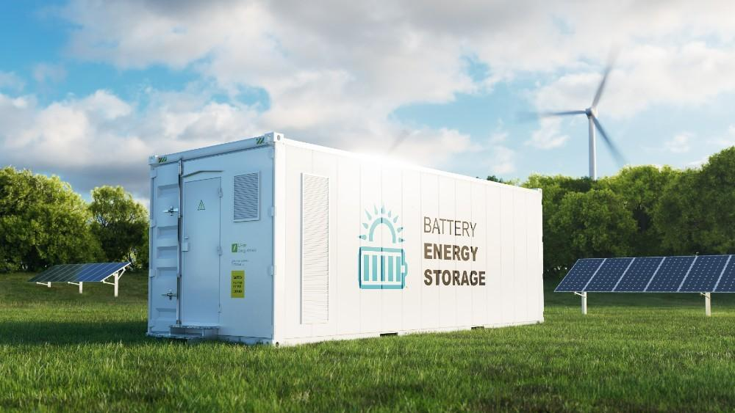

2.3.3 Sizing and Operational Strategies
The appropriate capacity for PV systems and associated battery storage is known as sizing. In sizing, various methods could be employed. Optimization-based sizing is mostly used in this context. Mixed Integer Linear Programming (MILP), which is a frequent means to validate and treat the sizing of PV systems, often consists of two optimized models [46].
These methods aim to reduce costs or improve benefits by ensuring the size of components like solar PV and battery storage is effectively optimized [47]. A good example is a study that determined why 96 Tesla Powerwall batteries are required and 120 kW PV panels due to results in optimization [48]. In other cases, the use of heuristic algorithms for sizing reveals different approaches, such as the Bat Algorithm for significant sizing and micro-grid management storage systems, and algorithms for PV system sizing with agent-based modelling [46].
In terms of operation, it dictates how batteries are being charged or discharged across time to ensure system performance is optimized. Optimization-based dispatch is a mathematical method that involves checking the preferable schedule format due to constraints and objectives (e.g., adjusting cost or savings), and a systemic coordinated design and dispatch co-optimization model. At the same time, this allows for capacity planning and operational scheduling that can effectively outperform conventional rules of thumb [47]. Receding Horizon Operation (RHO) / Model Predictive Control (MPC) is another method that involves solving a problem of optimization by implementing updated forecasts. RHO is considered a practical operation for batteries, as well as being compared with other methods of sizing [49]. This involves battery optimization being solved by operators, which predicts the parameters of the power system for a period of time ahead [49]. Strategies that incorporate this system approach, such as a rolling period of 72 hours, affect attaining the optimal cost of micro-grid [47]. This approach can lead to an elevated capacity of battery, minimize excess renewable generation, and a reduction in the total net present cost (NPC). All these are achievable by valuing the economics of mid-to-short-term arbitrage [47]. Optimization-based dispatch strategies could greatly reduce the curtailment of excess renewable energy [47].
Assumption foresight relates to the available data for the controller about expected conditions. On the other hand, perfect foresight is knowing future parameters (e.g., electricity prices, consumption) specifically across the entire sizing or planning horizon and is mostly used as an upper bound or in planning difficulties [49]. Forecast-based / rolling horizon operation implements predictions with inherent errors and updates over an inconsistent period, and receding operation in horizons. A good situation is where predictions are made for a unique period of time in the future [49]. Fuzzy logic is a unique method that can be implemented to reflect the uncertainty in PV forecasts when operation is optimized [50].
2.3.4 Key Findings and Research Gaps
This system provides clear technical benefits by improving the use of renewable energy and workflow performance, allowing more energy dominance, stability of the grid, and elevated flexibility of systems. Strategic choice in sizing and dispatch affects outcomes, such as comparing different BESS sizing scenarios to quantify both the impacts of the environment and finances. This allows the requirement for a more robust, arbitrage-aware optimal dispatch having a stochastic configuration and sizing pathway, which includes optimization over multi-day horizons rather than scheduling for just 24-hours. After all these positive means, gaps remain with real-world benchmarking and validation at a low point for community-scaled PV–BESS controls. There is insufficient handling of longer-horizon scheduling and sensitivity in foresight, with the need for more constraints on reporting to enhance comparability.
2.4 Electricity Tariffs and Market Structures
The structure of the electricity tariff and market design is a core requirement of the economic strength and operational means of PV–BESS systems. Households and communities face precise price signals, either in the form of flat rates, time-varying tariffs, or wholesale-indexed pricing. This constructs an incentive for charging and discharging, influencing decisions of investment, and ensuring how much value can be obtained from batteries. It is important to understand the principal structural retail tariff, export compensation means, regulatory framework, and the effect of tariffs on the economics of energy storage.
2.4.1 Retail Tariff Structures (Flat, TOU, Wholesale-Indexed)
The structures of retail tariffs present how households are charged for electricity, affecting financial incentives for investing in and using photovoltaic (PV) systems and battery storage. Some of these structures include flat, time-of-use (TOU), and wholesale-indexed tariffs, all of which have distinct effects on the consumption of energy and the storage mechanism.
Flat tariffs. A consistent price per kilowatt-hour (€/kWh) is considered for flat tariff charges regardless of any time throughout the day [53]. With respect to time, in some regions static tariffs are commonly used, which involve a fixed charge excluding demand charges [53]. Incentives are weakly provided by Flat tariffs, which results in a shift in use because the timing does not appear to be valuable for consumption or exports. This allows the obscuring of time-sensitive signals in price for household/community investment as well as the dispatch of PV battery systems [53]. This diminishes the financial drive for communities to change when electricity is being used [53]. The absence of incentives with respect to time for flat tariffs, especially when mixed with declining costs of PV battery and an increase in the tariffs, can still motivate individuals and communities to invest in PV-battery systems. This investment ensures the main goal is to maximize self-consumption value over exporting excess generated energy [53]. The adoption of PV batteries on a large scale under flat tariffs could influence transitional alteration in grid utilization. This can be a shift towards peak demand in the early morning as well as a shift to winter-dominant residual demand, which has a great impact on utility-scaled generators [53]. Economical rational decisions due to flat tariffs also steer towards peak feed-in from PV systems across many households, interjecting at noon, as there is no desire to change grid export timing [53].

Time-of-use (TOU) tariffs. These tariffs selectively show multiple electricity prices due to specific time blocks. A good instance is that electricity is cheaper at night, while in evening peak hours it is a lot more expensive. [54]. These tariffs can have distinguished values for peak, mid-peak, and even off-peak periods, with variations for working days, weekends, and even holidays [54].
Wholesale-indexed tariffs. In this instance, the fluctuations of the wholesale market directly cause the retail price of electricity, which can differ hourly or even every 15 minutes. The decisions of residential prosumers remain significantly independent of the signals of wholesale market price, retail tariffs, feed-in tariffs, and costs of PV investment. These all play important roles in shaping investment and making useful decisions [55]. TOU tariffs positively influence strategic battery use by making the price of electricity different throughout the entire day [54], while wholesale-indexed tariffs create the most dynamic signals, permitting the capitalization on market volatility of batteries, depending on how structured retail pricing and export remittance are [55].
2.4.2 Export Compensation Mechanisms (Net Billing, Net Metering)
The approach for export compensation involves the regulatory frameworks that create how individuals or entities receive credits or pay for excess solar photovoltaic (PV) electricity exported to the grid. This systemic approach significantly influences PV–battery systems' economic value by shaping whether it provides more edge to export surplus PV generation or has it stored for self-consumption at another time [56].
Net metering is a mechanism of compensation where solar PV energy that is exported is credited at, or very close to, a similar rate as energy imported, via kilowatt-hour (kWh) “netting” instead of a billing period [63, 64]. In net metering, the exported electricity to the grid has a value exhibited at the full retail price [57]. This concludes that the opportunity cost for exporting electricity is equivalent to the retail electricity tariff [57]. This mechanism ensures an attractive export, reducing the additional value derived from batteries. There has been a minimized incentive to have electricity stored when exports are compensated in great magnitude [56]. However, to manage PV exports, battery storage can also be used to undermine the intent of net-metering reforms by ensuring the issues of sales and revenue erosion are maintained for utilities [56]. In a net metering scheme, prosumers may decide to enlarge their PV capacity to sell electricity and attain a surplus that is much greater during peak as well as periods of mid-peak [58]. Under net metering, compared to net billing, investments in PVs and transmission tariffs tend to be enormous [58].
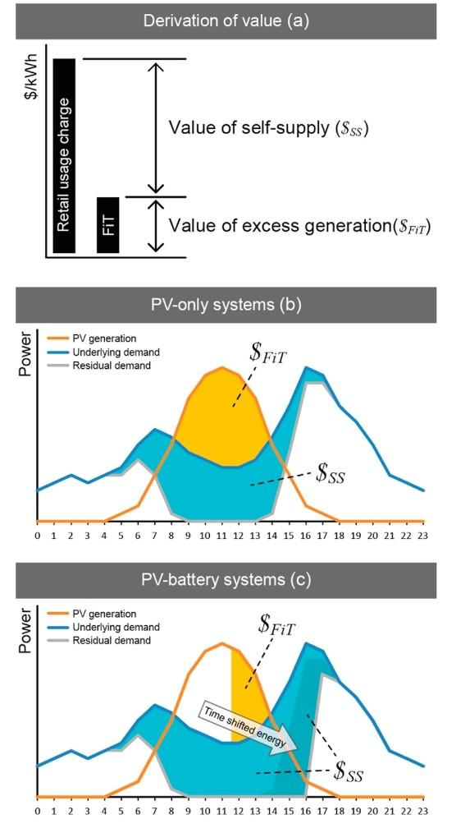
Net billing involves having pricing imports and exports, often crediting exports compared to imports at a much lower rate (€/kWh) [56]. This asymmetric pricing system means retail prices are increased and paid for solar PV that directly serves onsite load, while limiting (grid export) prices for PV-generated electricity exported to the grid [56]. These exports are commonly priced at a discounted rate, such as the generation charge instead of the full retail charges [57]. Some suppliers provided “virtual battery services” or tariffs that accommodate net billing for excess compensation [59]. Net billing provides opportunities for valuable self-consumption by increasing the value of batteries, as storing and ensuring electric generation sites provide more benefits than just exporting at a lower rate [56].
Figure X illustrates this logic by revealing that PV electricity that is self-consumed has a greater value than excess generated energy, which is exported. In the PV-only case, it is seen that excess midday PV is exported at a much lower value, while in cases of PV–battery, part of this excess energy is stored and adjusted to later periods of demand, increasing the value of self-supply.
Storage can be used by customers to arbitrage between retail and prices of grid export, effectively retaining the compensation retail rate for much of their PV production, which is similar to net metering [56]. However, this could result in a significant deadweight loss if there are large capital outlays for storage by customers primarily for this arbitrage [56]. In a net billing scheme, prosumers might not attain as large a surplus in the event of peak and mid-peak periods compared to a net metering scheme, in part as a result of having less PV capacity [58], and they tend to have less investment in PVs [58] Transmission tariffs fluctuation is more minimized under net billing, and increase in consumer surplus will be seen as PV capital costs declines [58].
Net metering has historically been the most common compensation structure in places like the United States [56]. However, there has been a shift towards net billing policies, for example, in the state of California, where the compensation export is considered based on locational net benefit analysis (LNBA) [57]. Similar cases have shown that the schemes of net metering and net billing can be designed to provide identical incentive levels. It is important to note that the export tariff under net billing has to be made high for subsidized retail tariffs to be compensated [57]. In summary, the incentives of net metering are obtained from exporting surplus PV due to high compensation, which reduces the need for batteries. Net billing, with lower export compensation, incentivizes self-consumption and storage, which helps improve the value proposition of batteries [56].
2.4.3 Spanish Electricity Market and Regulatory Framework
The Spanish electricity market and its regulatory framework ensure that there are clearly defined rules and price signals that a joint model system of Photovoltaic and Battery Energy Storage (PV-BESS) must adhere to. Over time, this framework has been transformed with recent regulations promoting self-consumption and influencing the profitability of such systems [67, 68].
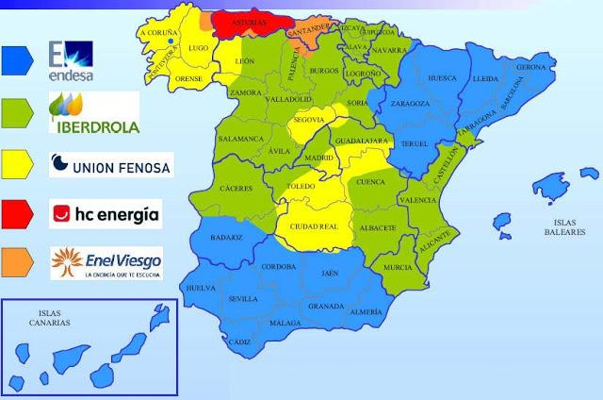
Wholesale reference: OMIE (Operador del Mercado Ibérico de Energía — Iberian Energy Market Operator) represents the Spanish day-ahead electricity market, where the wholesale price is made [60]. For PV-BESS models, the wholesale price of OMIE is used as the principal signal for understanding the spreads and volatility of price, specifically in situations that involve arbitrage or wholesale-indexed tariffs [60].
Retail settlement reference: PVPC (Precio Voluntario para el Pequeño Consumidor), a voluntary price for small consumers, is classified as Spain’s regulated retail tariff meant for small household consumers [61]. This dictates the price of retail import that different households essentially pay, which forms the basis of their electricity billing and settlement [61].
Simplified compensation and monthly cap (RD 244/2019): Under Royal Decree (RD) 244/2019, there is credit assigned to any surplus electricity exported to the grid by prosumers [62]. The monthly cap on credits is a crucial aspect of this regulation: in any given billing period (mostly monthly), the amount paid for imports cannot be exceeded by credit obtained by surplus exports [62]. A prosumer cannot receive more payment for their exports than what they consume from the grid. This regulation provides a significant impact on both the economic viability as well as measured value of PV-battery systems [62]. While the regulation advances self-sufficiency, exported electricity surpluses can dissuade likely residential adopters at low prices for PV-battery systems [67, 68]. This also tends to affect the profitability of PV self-consumption installations that lean heavily on the load profile and the rate of compensation [62].
Regulatory evolution and context: For photovoltaic generation, Spanish regulation has undergone various stages, beginning with subsidies in the early 1980s, which resulted in a sudden revelation in “Solar Orchards” around 2007–2008 [61]. Legal provisions from 2008 to 2010 subsequently aimed to reduce payments to renewable generating sources due to the financial constraint and other economic problems within the electricity system in Spain [61]. Abolishment of preferential prices in 2012 was established, which essentially replaces a complex direct remuneration system [61]. The current analyzed framework, in recent studies, showcases self-consumption and aims to ensure that the cost of supply in energy prices is avoided to distort the incentives of consumers [61]. Despite challenges in the past, local PV-battery installations are now considered a profitable option in Spain for cost savings or independence of the grid, especially if there is a continuous decline in the technological cost [62].
2.4.4 Impact of Tariff Structures on Storage Economics
The impacts of tariff structure in storage economics refer to how multiple designs of electricity tariff affect the financial viability and operational mechanisms of Battery Storage (BS). Essentially, tariffs construct the economic benefits and disincentives for implementing the use of batteries, which make up their overall value proposition [63].
Tariffs, specifically those with differentiation like Time-of-Use (TOU) or clearing price of the market, incentivize energy arbitrage, where during low-cost periods batteries charge and then discharge at periods of high cost [71, 72, 73]. There is significant bill reduction due to energy shifting for end-users; a good instance is integrating a battery that has a 3-8 period TOU tariff, which can minimize a bill by an estimate of 23% [64]. Tariffs also play a role in determining what customers pay for electricity from the grid and what they earn or are credited for exports to the grid [65]. A very significant factor is that low PV export tariffs motivate the utilization of self-consumption of generated electricity rather than exporting it to the grid [66].
Diverse structures of tariffs motivate the use of energy storage for different purposes. This may include energy arbitrage, energy shifting, solar self-consumption, as described earlier, or even import shaving [65]. However, the specific tariff a battery responds to influences how the storage system is used [66]. Tariff is designed to directly impact whether including BESS in the mix has an economic worth, by influencing metrics like Net Present Value (NPV) or payback period [63]. Also, tariffs that are capacity-based might not encourage battery system investment, whereas variations in higher tariffs, such as those in a spot market, could make the battery use more profitable [70, 72]. Tariff design is also useful in making desirable load profiles from community households with batteries [66]. Some of these tariff structures can result in elevated levels of customer imports and exports, ensuring the customer’s net load profile is promoted with an extreme ramp [65]. The economic viability of battery storage is significantly shaped by uniquely putting in place electricity tariff structures, which influence strategies in charging and discharging. This ultimately ensures financial returns from transactions in energy and ultimately affects profitable and adoptable rates of BESS [70, 75].
2.4.5 Key Findings and Research Gaps
In summary, PV–BESS profitability is structured by tariff design: we can see that flat tariffs can make for better economic performance compared to TOU tariffs, with a distinction in NPV of roughly 29–36% in a few instances. Export remuneration structure, which involves no remuneration, FIT, or NEM) was discussed, and the inclusion of demand charges (all-hours or peak-only) was also addressed. This essentially reforms the viability of PV–BESS, while flat tariffs can influence the systemic profile demand when energy export is considered. To attain the viability of BESS, it often demands the discrepancy in tariffs, while ensuring that low-level LCOE/LCOS is considered for financial feasibility. An important strategy discovered is charging BESS with cost-effective energy. Some relevant gaps to note include reduced knowledge of the impacts of broad household PV–BESS adoption on the system, like revenue/costs of the network, wholesale markets, and peak demand. Another factor is to ensure that multiple tariffs provide better outcomes for the entire system. It also allows questions to arise based on the lack of evidence on how a wide range of structural retail tariffs shapes long-term investment behavior, as well as ensuring the outcomes across seasons are well integrated. It also allows for accounting of the volatility of technology and electricity price through sensitivity analysis. Across multiple geographical tariff settings, the testing of conclusions, as well as addressing underexplored application facets, which include constraints in the sizing of BESS and limitations of household consumption.
2.5 Renewable Energy Communities
Renewable Energy Communities (RECs) consist of a promising example of institutional and organizational forms where multiple households, businesses, and other parties produce, share, manage, and sell locally generated renewable energy. The establishment of this system is closely tied to the European Union policy. There are also systemic changes made to governmental frameworks, and practical challenges for splitting both costs and benefits fairly among different participants.
2.5.1 Concept and Evolution of Energy Communities
The energy communities are an essential advancement in the energy sector, recognized by actions achieved in the production, sharing, and management of energy. The term “energy community” itself can appear in many different ways. It is known to be a familiar trend which is attributed to both consumers and prosumers working together for the community’s benefit [69]. This type of community is significantly a producing group of consumers (prosumers) who allow the sharing or sale of energy to the electricity grid or their community at large [69]. In an urban context, it is often understood as a geographical location specifically defined by physical properties having a socially tied environment [69]. Some relevant aspects constitute combined action by members to produce, share, manage, or trade energy within the same geographical scope. A defined location such as an individual building, a neighbourhood, or a city is a good example. Sometimes to a physical location they may not be strictly restricted to a physical location [69]. The size can even differ from buildings in groups to even a district. These communities can achieve multiple local objectives, including situations that include similar networks and a short transmission distance for shared electricity [69]. In local areas, the benefits of such projects among residents and their distribution are outcome dimension which are important. In the general public grid or operators, the energy communities can get involved in the network operations of distribution systems [69].
In earlier renewable communities, the concept has roots, and it now has different forms and names like community energy initiatives, energy cooperatives, renewable energy communities, smart energy communities, and prosumer communities. Thousands of enterprises like this worldwide can now be regarded as energy communities [69]. Multiple factors are what classify energy communities; these include their purpose, geographical focus, and their role as owners of small energy-related businesses or infrastructure [69]. The peer-to-peer trading as a form of sharing energy shows a significant form of development that focuses within the communities, which in recent times has been extensively examined [69].
Energy communities' emergence is driven by multiple factors, such as playing a role in achieving local objectives related to energy. They are also associated with decarbonization and localism, which seek to reclaim authority over the local economy [69]. The fixation of local benefits as well as the distribution of these benefits among residents underscores emphasis on local value and participation. These energy communities could also help reduce the impact of disruptions to delivered energy during local energy crises, promoting resilience in networks [69]. Certain defining features of communities are naturally related to energy communities, including local control and governance. It shows significant emphasis on shared benefits and how they are distributed among residents [69].
2.5.2 Governance and Operational Models
Fairness in energy communities (ECs) has been a significant problem, specifically around the allocation of collective costs and benefits derived from either shared assets or coordinated operations within the distribution grid [70]. As the growth of ECs continues and integrates with the grid, the fair distribution of operating costs among participants becomes increasingly complex [70].
A basic question is how local energy resources among members, especially those from jointly owned assets, should be distributed [71]. This allocation mechanism directly affects each member's electricity bill [71]. There is a need to determine fair means to ensure collective costs and benefits are allocated from shared assets or coordinated operations [70]. This includes allowing fair distribution of economic value among investors in joint energy assets [71]. Distribution of equitable infrastructure costs, such as installations of shared batteries or renewable energy sources (RES), is essential for fair investment strategies in large energy communities [70]. Ensuring fairness as a concept from other domains to energy systems is not of minimal importance due to certain issues involved [72]. The need for quantitative frameworks is important due to rigorously analyzing and optimizing different strategic allocation, moving beyond qualitative evaluations [72].

The formalization of the problem of fair energy resource allocation creates frameworks for understanding fairness in energy systems [72]. Cooperative game theory in energy communities is utilized for value allocation. The Shapley value is a common method in the payoff space that allows axiomatic fairness, which is considered the only value [71]. The stability of ECs under different technical conditions is well understood, showing that within the core, the Shapley value can be laid when there is a concave investment cost function for solar panels, which makes the game convex [71]. However, the Shapley value may be excluded from the game’s core if the community possesses a limited area for PV panels [71]. Strategies in management, like ensuring solar resources or adopting rental payments, are expanded. This can help ensure that durability in such cases is long-term [71]. In non-convex games, modifications to the Shapley value can also ensure stable coalitions [71]. For Community Energy Aggregators (CEAs), proposals may include fair cost allocation frameworks coordinated with multiple distributed energy resources (DER)[70].
2.5.3 Empirical Studies on Energy Community Performance
Studies show that using real-world data or specific case studies of Energy Community (EC) performance involves checking how these communities operate, which includes pilot projects, measured initiatives, surveys, or validated simulations using observed data [73]. These studies rely on multiple outcomes to assess the efficiency and effectiveness of these energy communities.
The outputs and performance of energy communities are both dependent on different factors, which encompass the specific design of the EC as well as the inherent motivations of all parties involved. This includes the need for cleaner energy supply, regulatory incentives, energy autonomy, grid stability, or reduction in the cost of electricity [73]. Different design options of energy communities directly impact both economic and environmental performance [73]. Technology features also affect performance, which includes the presence of distributed energy resources (DER), flexible equipment, or storage systems, and renewable energy generation [73]. The types of individuals involved (consumers and prosumers) with various electricity intensities and load profiles, even with agreement on electricity sharing within the community, also shape outcomes [73]. Energy consumption patterns within local energy communities are vital for overcoming obstacles in the assessment of performance [73]. Energy communities are essential for improving the European Union’s energy and climate objectives by contributing to the emissions of greenhouse gas reduction. This increases the share of renewable energy and promotes energy efficiency. This also ensures that the development of clear and understandable KPIs is essential for members of communities to react proactively and maximize benefits [73].
2.5.4 Performance Indicators and Drivers of EC Performance
Simulation-based modelling regarding Energy Communities (ECs) evaluates how these communities perform due to their design configurations, participant types, and technology assumptions [73]. The purpose is to assess the efficiency and effectiveness of ECs by focusing on different outcomes.
Key Performance Indicators (KPIs) are frequently used in empirical studies to assess the outputs of ECs, which cover multiple dimensions. Economic performance includes reducing the costs of community and individual [73]. Maximizing the economic benefits for community members [73] and considering factors like bill savings, Net Present Value (NPV), Internal Rate of Return (IRR), payback periods, and benefit distribution [73][75] are also economic performance. Technical performance can be peak reduction or the self-sufficiency and self-consumption rates of communities [73]. The overall energy performance of a local community and its actors is also summarized by well-defined indicators [73]. Energy produced, self-consumed, shared, injected, and withdrawn from the grid is monitored by these indicators. This ensures that users and the community can assess their effective action and conduct comparative analysis over time [73]. Equivalent CO₂ emissions savings, serving as a key indicator, are also assessed by what we call environmental performance [73].
For social and organizational performance, both participation and fairness are considered, including the benefits, acceptance, and effective governance [74][75]. Local energy communities are witnessed to be empowerment tool for consumers, making citizens more active participants in the energy sector [75]. Photovoltaic EC’s political, economic, and social dimensions are explored through an energy justice lens [74]. Implementation challenges like barriers to regulation, administrative complexity, and challenges in securing financing also shape performance outcomes of EC [75].
Energy communities' outputs and performance are dependent on different factors. Design options and participant motivations include the unique design of the EC and the motivations of participants. This includes the desire for cleaner energy supply, regulatory incentives, energy autonomy, stability of the grid, or minimized electricity costs [73]. Different energy community designs also provide an overall impact on economic and environmental performance [73]. Technological characteristics include the presence of multiple different technology features, such as distributed energy resources (DER), flexible equipment, or energy storage systems [73], and renewable energy generation. ECs provides aggregate consumers, producers, and prosumers with a virtual electricity meter to distribute, disperse, or sell energy produced within the community [73]. It is crucial to understand, while also identifying the key factors that drive their performance, the real-world impact and effectiveness of Energy Communities across economic, technical, and social dimensions.
2.5.5 Key Findings and Research Gaps
Spatial governance and planning actively play a role that is decisive in supporting renewable energy communities, and that legal and institutional problems often constrain the effort of distributed energy systems more than technology itself. In strategic energy and climate, spatial planning is frequently underused, and local planning of energy is often poorly aligned as well. This leads to missed opportunities for improving energy efficiency and facilitating investments in renewable energy. Priority on social, economic, environmental, or organizational aspects appears to be more dominant in renewable energy communities. The main gaps identified are the absence of spatial and multi-level institutional integration, the need to clarify suitable legal and regulatory barriers, and even frameworks required to understand how governance structures shape the engagement of stakeholders across various European contexts. It also highlights a financing gap for an appropriate transition, underscoring the need for funding approaches to be realigned to best support renewable infrastructure. Others may include capacity building, policy, and technology, particularly for marginalized groups and the global south.
2.6 Sensitivity and Uncertainty in PV–BESS Studies
The treatment of sensitivity and uncertainty is very important when discussing PV–BESS systems. It is essential to examine how key input assumptions, like battery costs, electricity prices, forecast accuracy, and community composition, have an effect on shaping economic and operational results. It also audits the analytical mechanism used to characterize and present these uncertainties.
2.6.1 Battery Cost Trajectories in the Literature
Battery CAPEX has declined and presents a replacement cost uncertainty via multiple means, which include scenario-based projections and sensitivity analysis. These assumptions of battery cost often dominate the conclusions of profitability, which is due to their tremendous effect on the overall cost of ownership.
There are often multiple developed trajectories for battery pack costs, which instigate different possible values. A good example is a study that derived three trajectories for pack costs of lithium-ion battery (LIB), which range from 64 to 255 $/kWh in the year 2050 [76]. Another study estimated that by 2025, LIBs are set to have the lowest cost in capital by setting a system based on arithmetic means and a capital cost improvement of 5% conducted annually [76]. There is a good belief in the declining cost of batteries as well as their transformative impact [76]. Studies also show how the cost-learning curve factors like high-silicon or solid-state anodes can steepen, ensuring the reduction of the share of total cost of ownership (TCO) variance linked to battery price [77]. Sensitivity checks are carried out around influential parameters like the trajectory of battery price, electricity and fuel prices, and residual value assumptions [77], and battery price learning is an important driver, which accounts for closely half of the year-to-year variance in TCO [77]. Bottom-up modelling reveals progressive specific uncertainties: solid-state battery (SSB) costs exhibit a wide range due to lithium metal foil cost uncertainties and lithium depletion during operation [76]; batteries of lithium-sulfur (LSBs) face uncertainties that are related to the content of usable sulfur [76], and market dynamics of lithium-ion batteries, which also introduce ambiguity into projected costs [78]. In addition, approaches of expert elicitation gather expert opinions and their expected impact on battery costs from science and industry regarding optimal R&D investment [76].
Assumption of battery cost significantly influences profitability conclusions because they are a main driver of the total cost of ownership. Lower battery costs lead to an increase in the deployment of BSS and a greater share of renewables. This ultimately causes a decline in the reliance on natural-gas-powered energy generation [76]. The pace of battery cost learning accounts for a substantial portion of the variance in the total cost of ownership [77]. While factors like residual value uncertainty and revenue of vehicle-to-grid (V2G) can affect outcomes, they typically do not overturn the fundamental cost logic driven by battery learning [77]. However, the prices of balance-of-system (BOS) show slower learning compared to the prices of the whole system, this occurs as their share relative to battery pack prices increases [79].
2.6.2 Impact of Electricity Price Volatility
When integrated with Photovoltaic (PV) systems, electricity price volatility significantly influences the profitability of Battery Energy Storage Systems (BESS), specifically through energy arbitrage strategies. This impact is mainly driven by the average price level, the degree of price volatility, and the spread between prices that are both low and high.
Energy storage traders involved in electricity markets use the volatility of prices to make a profit from price differences by purchasing electricity when prices are low and selling at a period when they are high [80]. This also ensures grid operations by limiting peak demands [80]. The degree of price fluctuations can be seen by the spread and skewness of the hourly electricity price distribution in histogram format [81]. A bigger spread with a long tail toward elevated prices reveals a volatile market with potential for high benefits but also has significant risks [81]. In high-spread volatile markets, rapid charging and discharging are important to capture price spikes required [81]. Also, in markets of better stability, longer and lower-powered charging modes are considered to reduce the cost of operation [81]. A lower standard deviation in electricity prices, indicating more stable prices, discourages BESS energy arbitrage operations that are profitable, which are required to justify the high capital expenditure (CAPEX) of such ventures [81]. What arbitrage strategies earn from is known to be the difference between low-price and high-price periods (price spread). A higher average hourly price difference (AHPD) reveals greater profit potential [81]. A narrow spread with a concentrated peak around a moderate price range shows a more stable market with lower returns and minimal risks [81].
Wholesale electricity prices are situated with short-term (hourly/daily) fluctuations driven by renewables and longer-term variability influenced by fossil fuel and carbon prices [82]. Fluctuations can occur in these prices around high or low averages over many years [82]. Annual variations can also be linked to natural gas prices that fluctuate consistently. It also applies to transmission congestion and global market dynamics [80]. Future power prices with increased volatility can affect revenues and elevate the cost of capital for merchant renewable generators [82]. Current and future wholesale electricity price volatility has significant impacts on the cost of capital for new renewable projects [82] as well as investment returns [82]. Current electricity and BESS prices can lead to competitive investments for PV+BESS systems irrespective of uncertainties, or at the very least investments close to break-even. This uniquely depends on the specific use case, such as ancillary services and arbitrage [33].
2.6.3 Forecast Uncertainty and Value Erosion (Arbitrage/Self-Consumption)
The uncertainty of forecasts significantly impacts the economic value of photovoltaic (PV) and battery energy storage system (BESS) operations, leading to erosion in value compared to scenarios considering perfect knowledge of future conditions. The nature of forecast errors is important, showing their financial implications and approaches to managing them.
Perfect foresight models, which take the exact knowledge of future PV generation, demand, and prices, represent the highest achievable arbitrage or value of load-shifting. This ideal scenario is not attainable in real-world systems [83].
Forecast errors are a major source of uncertainty for PV generation, which appears different from its inherent variability [83]. Typically, these errors increase as the forecasting horizon extends [83]. Forecasts of PV, load, and price are all subject to errors [83], and errors of solar forecast can lead to errors in electricity price forecasting, which naturally in turn affects the profitability of the electricity market [83]. There can be substantial costs of these errors when compared to the levelized cost of electricity from PV systems [83]. The cost of PV forecast errors can be derived by excluding the operational cost with a perfect PV forecast from the incurred cost with an imperfect forecast [83]. The range of this cost can be from 0.2 to 6 USD/MWh for PV penetration levels between 0% and 30% [83].
In charge/discharge timing for BESS, forecast errors cause “missed” opportunities, reducing the achievable savings or profit compared to the perfect-foresight case, and this is known as value erosion [83]. At low PV penetration, solar forecast errors, which are negatively correlated, might even reduce system imbalance and allow PV operators to be compensated for errors in certain markets [83]. Higher PV penetration is loosely linked with elevated error costs; the cost of forecast errors does not always increase with more penetration [83]. In reality, the cost of forecast errors can be minimal compared to the reduction in capacity of PV and energy value when there is an increase in PV penetration from 0% to 30% [83]. Even if PV generation could be perfectly forecasted, removing uncertainty, the system can contend greatly with variability, as well as the cost associated with PV variability. This has been revealed to be much higher than the cost of solar forecast errors at high levels of PV penetration [83].
The knowledge of forecast value and the cost of their errors is essential for improving PV penetration and decarbonization strategy [83]. The value of forecast improvement is the savings obtained from ensuring more actual forecasts [83]. There is diminishing return in improving the forecast accuracy of solar energy, as uncertainty from other sources like load will always remain [83]. There is limited reported data on the cost of solar forecast errors and the value of solar forecasts to definitely determine how the economics of solar forecasting vary with PV penetration [83]. Extended reviews aim to address this gap by investigating the value and cost across multiple power system levels; this includes transmission, distribution, microgrid, and household levels [83].
2.6.4 Influence of PV Penetration and Community Composition
The effect of photovoltaic (PV) penetration and community composition on energy outcomes, specifically regarding PV-Battery Energy Storage Systems (BESS), involves how increased PV capacity and different household characteristics affect energy use, demand, generation, and storage.
Increased levels of solar PV penetration result in a substantial reduction in the total energy demand per household, particularly between 8:00 AM and 4:00 PM [84]. Conversely, it results in a substantial increase in the generation ramping capability between 3:00 PM and 6:00 PM [84]. Models of energy demand are most affected by the penetration of rooftop solar PV during spring and summer [84]. While the community demands of high PV penetration are not at the moment highly correlated with zone or regional demand. However, the trend lines suggest an increasing correlation over time [85]. The correlation seen between community peak demand and upper levels is consistently elevated during summer periods [85]. It has been seen that PV has the most important impact on community demand between 8 AM and 4 PM. While central air conditioning loads show more impact during other hours, especially from 4 PM to 8 PM for individual units [85]. Investigation has shown that the correlation of residential community demand within high PV penetration, and with zone and regional demand [85]. This involves allowing modified season-wise demand models of energy, which could incorporate the effect of high rooftop solar PV penetration, considering moments like a fixed number of households with PV installed [84].
Community composition, like household types and structural settlement, plays a crucial role in PV uptake and profitability. Households experience greater profits when electricity is shared within larger communities. In smaller communities sharing electricity with more households also elevates the optimal size of the most profitable PV system, with a more pronounced effect [86]. PV uptake in a region relies on its own adopter characteristics and settlement structure, compared to those around them [87]. Multiple factors like solar irradiation, detached houses, electricity demand, and county area shows a positive PV uptake [87]. Large rural regions with higher shares of detached single or double-family houses impact PV uptake positively, as detached houses allow for better solar exploitation generally due to less shadowing and bigger roofs [87]. PV adoption of households tends to increase with higher demand of electricity [87]. Owner-occupied buildings are also associated with increased adoption of PV, as owner-occupiers may have greater financial capacity and a better decision-making process when it comes to installation [87].
Increasing installations of PV and adoption rates of prosumers can lead to a higher Internal Rate of Return (IRR), as more available energy for peer-to-peer (P2P) trading allows PV system owners to achieve better economic outcomes, regardless of the magnitude of their electricity demand [73]. PV sizing with high-solar fraction can be taken as the most feasible for creating energy communities [73].
2.6.5 Approaches to Sensitivity and Scenario Analysis
A crucial tool in simulation models that helps researchers understand how alterations in input variables affect the outputs of the model is referred to as Sensitivity analysis (SA). Under various conditions, this ensures revealing the model’s robustness and reliability [88]. To extreme values of model input factors or radical changes in the model’s structure, it systematically searches for simulation responses [88]. SA contributes to analysing the relationship between both the variance of independent input variables (x) and dependent output variables (y) [88].
SA supports quantifying the effect of individual input variables on output values, identifying key features, and enhancing the accuracy and predictive power of models [88]. Linear or nonlinear regression analysis and Analysis of Variance (ANOVA) can be used sometimes to make both analysis and representation of dependencies between input factors and the responses of outputs [88]. After conducting SA, a thorough and complete data flow analysis and interpretation of the data, often using graphical representations. Examples of these representations include tornado charts or scatter plots for intuitive understanding [88]. Different individual parameters, a requirement of SA, can sometimes affect the internal consistency of scenarios negatively by combining implausible parameter combinations [89]. Showing available data, the selection of an appropriate SA method depends on the model characteristics [88].
2.6.6 Key Findings and Research Gaps
This concludes that uncertainty is an important driver of PV–BESS operational and economic outcomes instead of a secondary detail, with recurring sources that include the battery cost trajectories, volatility of electricity price, forecast error, PV penetration, and community composition. It shows that many studies remain closely tied to unique case-study contexts and modelling assumptions, which reduces to other local energy system settings how transferable their conclusions are. A major gap is the limited systematic evidence on which forecast types and characteristics most improve optimisation-based decision outcomes. The meaning that a forecast is often assessed without a clear link to a relevant decision. As a result, SA provides a context for the need for a structured and transparent sensitivity framework that allows explicit assumptions and tests robustness. This ensures comparability across clearly defined dimensions of uncertainty, improves comparability across cases, and makes the interpretation stronger by directly connecting outcome scenarios to the most important uncertainties in PV–BESS analysis.

2.7 Literature Synthesis and Research Gap

2.7.1 Key Insights from Existing Literature
The preceding review of techno-economic assessment, value streams, community-scale systems, tariff design, energy communities, and sensitivity analysis reveals several converging insights that frame the present study.
Economic viability is strongly context-dependent. The profitability of PV–BESS systems depends on the interplay between retail electricity prices, export remuneration mechanisms, battery capital costs, and local demand patterns [1], [3]. Studies consistently show that positive returns are scenario-dependent rather than generic, with the gap between retail import prices and export compensation emerging as a critical economic driver [3]. In Spain, the regulatory framework established by Royal Decree 244/2019 has catalyzed collective self-consumption, yet the simplified compensation mechanism—which caps monthly export credits at the value of imported energy and prohibits carry-over—introduces settlement constraints that are not universally modeled in the broader literature.
Battery storage enhances self-consumption but value attribution remains unclear. Integrating battery energy storage with PV systems significantly increases solar self-consumption, reduces grid exports, and enables limited energy arbitrage [22], [39], [43]. At the community scale, aggregating PV and BESS can yield capacity savings (e.g., 22% reduction in BESS capacity at 100% PV penetration) and shorter payback periods due to economies of scale [51]. However, the reviewed literature often discusses the combined value of PV + storage systems without a clear methodology for isolating and attributing the specific value added by the battery component, independent of the PV system [31]. This attribution gap is particularly relevant for community decision-makers evaluating whether to add shared storage to an existing or planned PV installation.
Tariff structure profoundly influences PV–BESS economics. Flat tariffs can outperform time-of-use (TOU) tariffs for PV+BESS systems in some contexts, with NPV differences ranging from 29% to 36% [54]. The presence or absence of export remuneration, the structure of demand charges, and the alignment of tariff peaks with local demand patterns all shape the economic viability of storage [65], [66], [67]. Yet, there remains a critical need to explore the broader systemic impacts of widespread PV–BESS adoption and the effectiveness of diverse tariff structures across different regulatory environments [60], [75], [82]. In particular, the Spanish PVPC indexed retail price and the simplified compensation export-credit mechanism represent a specific settlement environment that has not been systematically modeled in comparative PV–BESS studies.
Dispatch realism and forecast assumptions are critical but underexplored. Perfect foresight assumptions can overestimate PV–BESS value by approximately 1–8% [16]. Algorithmic dispatch strategies may not fully capture opportunities for load shifting, sub-hourly variability, or real-time control constraints [16]. Despite the widespread use of deterministic and probabilistic forecasts in stochastic optimization, the literature provides limited systematic evidence on which forecast types and characteristics most improve decision-making outcomes in practice [91]. This gap is compounded by the fact that many studies remain strongly tied to unique case-study contexts and modeling assumptions, reducing the transferability of their conclusions to other local energy system settings [91].
Sensitivity analysis is essential but often narrow in scope. Sensitivity analysis (SA) is a crucial tool for understanding how alterations in input variables affect model outputs and for revealing the robustness and reliability of simulation models [88]. However, many studies test individual parameters in isolation, which can negatively affect the internal consistency of scenarios by combining implausible parameter combinations [89]. A structured and transparent sensitivity framework that tests robustness across clearly defined dimensions of uncertainty—such as battery CAPEX, PV penetration, community composition, and tariff volatility—is needed to improve comparability across cases and strengthen the interpretability of results [91].
Community composition and spatial governance matter. The economic performance of energy communities is influenced by the number of participants, the diversity of load profiles, and the degree of PV penetration [73], [86], [87]. Larger communities with heterogeneous demand patterns can achieve higher self-consumption ratios and better economic outcomes [73]. However, the literature on energy communities has primarily focused on social, economic, and environmental benefits or organizational models, often trivializing the spatial governance and planning dimension [74]. In the Spanish context, where activation policy is defined at national and regional levels but implemented at the municipal level, there is a need for empirical analysis that reflects the specific institutional and regulatory environment [74], [75].

2.7.2 Limitations in Current Research

A. Narrow Sensitivity Coverage
A recurring limitation across the reviewed literature is the narrow scope of sensitivity analysis. While many studies acknowledge uncertainty in key parameters such as battery costs, electricity prices, and demand patterns, they often test these parameters individually or in limited combinations [88], [89]. This approach can produce internally inconsistent scenarios—for example, pairing low battery costs with high electricity prices in ways that do not reflect plausible future market conditions. Furthermore, sensitivity analyses frequently focus on a single dimension of uncertainty (e.g., battery CAPEX) while holding other critical variables constant, such as PV penetration level, community size, or tariff structure [66], [67].
The lack of multi-driver sensitivity analysis limits the ability to identify interaction effects and threshold conditions. For instance, the economic viability of community battery storage may depend not only on battery CAPEX in isolation, but on the joint effect of battery cost, PV penetration, and the number of participating households. Without systematic exploration of these interactions, studies risk overgeneralizing findings from a narrow set of assumptions or failing to identify the conditions under which storage becomes economically viable [91].
Additionally, many studies do not explicitly report the range of parameter values tested, the rationale for selecting those ranges, or the sensitivity of results to forecast assumptions (e.g., perfect foresight vs. day-ahead forecasts) [16], [91]. This lack of transparency reduces comparability across studies and makes it difficult for practitioners and policymakers to assess the robustness of reported findings.

B. Limited Benchmarking Against PV-Only Baselines
A second major limitation is the absence of systematic benchmarking against PV-only baselines. While the literature extensively documents the combined benefits of PV+BESS systems—such as increased self-consumption, reduced peak demand, and energy arbitrage—it rarely quantifies the incremental value attributable to the battery alone [31]. This omission is problematic for several reasons.
First, it obscures the true economic contribution of storage. A PV+BESS system may deliver positive NPV, but if a PV-only system under identical conditions delivers nearly the same NPV, the battery adds little incremental value and may not justify its capital cost. Without a PV-only counterfactual, it is impossible to determine whether observed benefits stem primarily from the PV system or from the storage component [31].
Second, the lack of PV-only benchmarking complicates investment decision-making for energy communities. Community organizers and investors need to know not only whether a PV+BESS system is profitable, but whether adding storage to a planned or existing PV installation is economically superior to deploying PV alone. This question is particularly relevant in regulatory environments like Spain, where the simplified compensation mechanism caps monthly export credits and introduces a “use-it-or-lose-it” constraint that may limit the value of surplus PV generation [RD 244/2019]. If a PV-only system already captures most of the available economic benefit under these settlement rules, the incremental value of storage may be marginal.
Third, the absence of PV-only baselines hinders the identification of battery-specific value streams. While the literature discusses self-consumption enhancement, peak shaving, and arbitrage as distinct value streams, it rarely decomposes these streams to isolate the battery’s contribution [31]. For example, a PV system alone can increase self-consumption by directly offsetting daytime load; the battery’s incremental contribution is the additional self-consumption achieved by time-shifting PV generation to evening hours. Without explicit decomposition, the relative importance of different value streams—and the conditions under which they materialize—remains unclear.
Finally, limited benchmarking reduces the comparability of results across studies. Different studies may report different metrics (e.g., NPV, payback period, self-consumption ratio) for PV+BESS systems, but without a common PV-only reference case, it is difficult to assess whether differences in reported outcomes reflect differences in battery performance, PV system design, tariff structure, or modeling assumptions. A standardized approach that includes both PV-only and PV+BESS scenarios would improve transparency and facilitate cross-study comparison [25], [37].

2.7.3 Identified Research Gap
The synthesis of existing literature and the limitations outlined above reveal a clear research gap at the intersection of four dimensions: PV-only comparison, battery value stream attribution, Spanish tariff and settlement realism, and multi-driver sensitivity analysis.
First, the absence of systematic PV-only benchmarking means that the incremental economic value of community battery storage—relative to a PV-only collective self-consumption baseline—remains unquantified in most studies. This gap is particularly acute in the context of energy communities, where the decision to add shared storage to a planned or existing PV installation requires a clear understanding of the battery’s marginal contribution to economic performance. Without a PV-only counterfactual, community organizers cannot determine whether the additional capital cost of storage is justified by incremental benefits, or whether most of the economic value is already captured by the PV system alone.
Second, the literature lacks a transparent framework for decomposing battery-specific value streams. While studies discuss self-consumption enhancement, peak shaving, and energy arbitrage as distinct mechanisms, they rarely isolate the battery’s contribution to each stream or quantify how these contributions vary with system configuration, tariff structure, and community composition. This gap limits the ability to identify which value streams are most important under different conditions and to design dispatch strategies that maximize battery-specific value.
Third, the Spanish regulatory and settlement environment is underrepresented in the PV–BESS literature. The simplified compensation mechanism established by RD 244/2019—which caps monthly export credits at the value of imported energy and prohibits carry-over—introduces a settlement constraint that is not captured by generalized net-billing or net-metering models. Many studies approximate export settlement using assumptions that allow surplus energy to be fully monetized, which can systematically overstate storage value or misidentify sizing thresholds. The missing quantitative link is the battery-specific value under Spanish import/export valuation rules, including the effect of the monthly compensation cap on the economic viability of community storage. Without this, community organizers, investors, and policymakers lack decision-grade guidance on viable CAPEX ranges, PV penetration regimes, and community compositions for shared storage adoption in Spain.
Fourth, existing sensitivity analyses are often narrow in scope and do not systematically explore the joint effects of multiple drivers. While individual parameters such as battery CAPEX or electricity price volatility are frequently tested, the interaction effects between battery cost, PV penetration, community size, and tariff structure remain underexplored. This gap limits the ability to identify threshold conditions—such as the minimum PV penetration level or maximum battery CAPEX at which storage becomes economically viable—and to assess the robustness of findings across plausible future scenarios. A structured, multi-driver sensitivity framework that tests combinations of key parameters and explicitly reports the range of conditions under which storage adds value is needed to improve the transparency and comparability of PV–BESS assessments.
In summary, the identified research gap is the lack of a Spain-specific, PV-only-benchmarked, battery-value-decomposed, and multi-driver-sensitivity-tested techno-economic assessment of community PV–BESS systems. Addressing this gap requires an explicit implementation of RD 244/2019 settlement rules, a transparent methodology for quantifying battery-specific value relative to a PV-only baseline, and a systematic sensitivity analysis that explores the joint effects of battery CAPEX, PV penetration, and community composition on economic outcomes.

2.7.4 Contribution of the Present Study
This thesis addresses the identified research gap by providing a Spain-specific, PV-only-benchmarked, battery-value-decomposed, and multi-driver-sensitivity-tested techno-economic assessment of co-located PV and community battery energy storage systems in energy communities. The primary contributions are organized around three pillars: settlement realism, value attribution, and robustness analysis.
First, explicit settlement implementation (Spain-specific). This study provides an auditable implementation of the RD 244/2019 monthly export-credit cap and no-carry-over rule within a techno-economic simulation of collective self-consumption. Grid imports are valued using the Spanish regulated PVPC retail price series, and exports are valued using the simplified-compensation export-credit series, subject to the monthly cap constraint. This implementation reflects the actual settlement environment faced by Spanish energy communities and avoids the systematic overestimation of storage value that can result from generalized net-billing or net-metering assumptions. By modeling the “use-it-or-lose-it” monthly ceiling, the study quantifies when and how the compensation cap binds, and how this constraint affects the economic viability of community battery storage.
Second, value decomposition of storage benefits. This study introduces a transparent framework to quantify battery-specific value relative to a PV-only baseline, defined primarily as incremental economic value (e.g., ΔAnnual Bill and/or ΔNPV). This framework is supported by explanatory technical indicators such as the change in Self-Consumption Ratio (ΔSCR) and the measured volume/value of avoided “lost export credits” when the monthly cap would otherwise bind. By comparing PV+BESS outcomes to a PV-only counterfactual under identical inputs (same load, PV, tariff, and settlement rules), the study isolates the battery’s marginal contribution to economic performance and identifies the conditions under which storage adds meaningful value. This approach directly addresses the attribution gap identified in the literature and provides decision-grade guidance for community organizers evaluating whether to add shared storage to a planned or existing PV installation.
Third, robustness and threshold insights through multi-driver sensitivity analysis. This study conducts a structured sensitivity analysis to identify viability envelopes and break-even conditions across battery CAPEX, PV penetration, and heterogeneous community composition (10–50 households), under Spanish pricing inputs and settlement constraints. Unlike studies that test individual parameters in isolation, this analysis explores the joint effects of multiple drivers and explicitly reports the range of conditions under which storage becomes economically viable. This multi-driver approach improves the transparency and comparability of results, strengthens the interpretability of findings, and provides robust guidance for practitioners and policymakers navigating uncertainty in battery costs, PV deployment levels, and community characteristics.
Fourth, methodological transparency and reproducibility. The study employs a rule-based dispatch strategy that is transparent, interpretable, and consistent across scenarios, avoiding the “black-box” nature of some optimization-based approaches. The dispatch logic, settlement calculations, and allocation mechanisms are explicitly documented, enabling reproducibility and facilitating comparison with other studies. While battery degradation is not modeled (a limitation acknowledged and recommended for future work), the focus on pricing, dispatch logic, and allocation impacts ensures that the core research questions—concerning the incremental value of storage under Spanish settlement rules—are addressed with clarity and rigor.
In summary, this thesis contributes to the PV–BESS literature by providing the first systematic, Spain-specific assessment of community battery storage that explicitly models RD 244/2019 settlement rules, quantifies battery-specific value relative to a PV-only baseline, and explores the joint effects of battery CAPEX, PV penetration, and community composition through a structured sensitivity framework. These contributions directly address the research gaps identified in Section 2.7.3 and provide actionable insights for energy community organizers, investors, and policymakers in Spain and similar regulatory environments.

Comparison Table: Selected Studies and This Thesis
The following table compares five representative studies from the literature with the present thesis across key dimensions: context, tariff model, export compensation, dispatch type, foresight assumption, allocation method, sensitivity coverage, and the specific contribution of this thesis.
Study | Context | Tariff Model | Export Compensation | Dispatch Type | Foresight Assumption | Allocation Method | Sensitivity Coverage | This Thesis Adds…
Saurabh et al. (2025) [1] | Domestic PV–battery systems, Spain | PVPC retail price | Simplified compensation (RD 244/2019) | Not explicitly detailed | Not specified | Single household (no allocation) | Battery cost, electricity price | PV-only baseline comparison; explicit monthly cap implementation; community-scale allocation; multi-driver sensitivity (CAPEX × PV penetration × community size)
Sandelic et al. (2022) [2] | Urban PV potential, Spain (net billing vs. net metering) | PVPC retail price | Net billing and net metering scenarios | PV-only (no storage) | Not applicable | Single household or building | PV capacity, tariff structure | Addition of community battery storage; battery-specific value decomposition; explicit RD 244/2019 monthly cap; community composition sensitivity
Barbour et al. (2018) [31] | Residential PV + storage, various pricing scenarios | Flat, TOU, and dynamic pricing | Various (including no export, net metering, wholesale price) | Optimization-based (perfect foresight and day-ahead) | Perfect foresight and day-ahead forecast | Single household (no allocation) | Pricing mechanism, grid constraints, inverter sizing | Spain-specific settlement (PVPC + simplified compensation); PV-only baseline; community-scale allocation; systematic multi-driver sensitivity
Parra et al. (2017) [51] | Community-scale PV–BESS aggregation, generic European context | Generic retail tariff | Feed-in tariff or self-consumption | Optimization-based | Not specified | Aggregated community (no individual allocation) | PV penetration, BESS capacity | Spanish tariff and settlement realism (PVPC, RD 244/2019 monthly cap); transparent allocation mechanism; battery-specific value attribution; multi-driver sensitivity (CAPEX × PV penetration × community size)
Hanna et al. (2014) [66] | Household PV + battery, Australia | Flat and TOU tariffs | Feed-in tariff | Rule-based (self-consumption priority) | Not specified | Single household (no allocation) | Tariff structure, battery cost, PV capacity | Spain-specific settlement (PVPC + simplified compensation with monthly cap); PV-only baseline; community-scale allocation; systematic multi-driver sensitivity; explicit reporting of threshold conditions
This Thesis (2026) | Community PV–BESS, Seville, Spain | PVPC retail price (quarter-hourly from 2026) | Simplified compensation (RD 244/2019) with monthly cap and no carry-over | Rule-based (transparent, interpretable) | Day-ahead OMIE price signal | Static sharing coefficients (transparent, reproducible) | Battery CAPEX, PV penetration, community composition (10–50 households), joint effects | First systematic Spain-specific assessment with explicit RD 244/2019 monthly cap implementation; transparent PV-only baseline for battery-specific value attribution; multi-driver sensitivity framework exploring joint effects of CAPEX, PV penetration, and community size; actionable threshold insights for Spanish energy communities
Table 2.1: Comparative overview of selected PV–BESS studies and the present thesis. The table highlights the specific contributions of this thesis in addressing the identified research gaps: Spain-specific settlement realism, PV-only benchmarking, battery value decomposition, and multi-driver sensitivity analysis.

References
[1] Techno Economic Analysis of Grid Connected Photovoltaic Systems With Battery Energy Storage: A Comprehensive Review
[2] Impact of Power Converters and Battery Lifetime on Return of Investment of Photovoltaic Systems
[3] Economics of Residential Photovoltaic Battery Systems in Germany: The Case of Tesla’s Powerwall
[4] Economics of Residential PV Battery Systems in the Self-Consumption Age
[5] On the Evaluation of Subsidy-free Grid-Connected PV Systems in Sunny Countries: an Economic Assessment
[6] Techno-Economic Analysis for the Profitability of Residential PV-Battery System
[7] Modified Levelized Cost of Electricity or Energy, MLOCE and Modified Levelized Avoidable Cost of Electricity or Energy, MLACE and Decision Making
[8] System LCOE: What Are the Costs of Renewables?
[9] Stochastic NPV Based vs Stochastic LCOE Based Power Portfolio Selection Under Uncertainty
[10] A Quantitative Assessment of the Economic Viability of Photovoltaic Battery Energy Storage Systems
[11] Real-World Performance and Economic Evaluation of a Residential PV Battery Energy Storage System Under Variable Tariffs: A Polish Case Study
[12] Techno-Economic Analysis of Residential-Scale PV and PV+BESS Systems
[13] Techno-Economic Assessment of PV-Coupled Battery Energy Storage Systems with Different Sizing Methodologies
[14] Techno-Economic Assessment of the Missing Opportunities for Prosumagers: The Dutch Case
[15] Batteries in PV Systems: A comprehensive analysis of performance, efficiency and cost in personal house use
[16] Impacts of Dispatch Strategies and Forecast Errors on the Economics of Behind-the-Meter PV-Battery Systems
[17] Battery Energy Storage Systems in Different Countries for Arbitrage Services
[18] OPTIMAL ENERGY STORAGE SOLUTION TO REDUCE ELECTRICITY BILLS FOR CUSTOMERS WITH HIGH CAPACITY DEMAND – CLASS-A CUSTOMERS IN ONTARIO
[19] A Simple Operating Strategy of Small-Scale Battery Energy Storages for Energy Arbitrage under Dynamic Pricing Tariffs
[20] “Market value: Making money,” in Monetizing Energy Storage
[21] Daily Episodic and Continuous Arbitrage Trading With Electric Batteries
[22] On-site solar PV generation and use: Self-consumption and self-sufficiency
[23] Optimization of the integration of photovoltaic systems on buildings for self-consumption – Case study in France
[24] THE EFFECTS OF BATTERY STORAGE AND LOAD MANAGEMENT ON PHOTOVOLTAIC SELF-CONSUMPTION
[25] Enhancing self-consumption for decarbonization: An optimization strategy based on a calibrated building energy model
[26] Methods for Increasing Shares of Self-Consumption in Small PV Solar Energy Applications
[27] A Case Study of the Use of Smart EV Charging for Peak Shaving in Local Area Grids
[28] Peak Shaving Mechanism Employing a Battery Storage System (BSS) and Solar Forecasting
[29] A peak load shaving strategy for end-user consumers
[30] Joint Energy Disaggregation of Behind-the-Meter PV and Battery Storage: A Contextually Supervised Source Separation Approach
[31] Private vs. public value of U.S. residential battery storage operated for solar self-consumption
[32] Establishing the Stacked Value of Battery Energy Storage in Electric Power Systems
[33] COMPARATIVE PROFITABILITY ASSESSMENT OF PV + BESS FOR DIFFERENT CONFIGURATIONS AND BUSINESS MODELS
[34] Assigning value to energy storage systems at multiple points in an electrical grid
[35] Battery Storage for Ancillary Services in Smart Distribution Grids
[36] A review of battery energy storage systems for ancillary services in distribution grids: Current status, challenges and future directions
[37] Transmission-Scale Battery Energy Storage Systems: A Systematic Literature Review
[38] A Utility-Scale Deployment Project of Behind-the-Meter Energy Storage for Use in Ancillary Services, Energy Resiliency, Grid Infrastructure Investment Deferment, and Demand-Response Integration
[39] Optimal peak-shaving for dynamic demand response in smart Malaysian commercial buildings utilizing an efficient PV-BES system
[40] Modeling and Performance Analysis of Battery Energy Storage Incorporated Grid-Connected Photovoltaic Plants
[41] Energy community with shared photovoltaic and storage systems: influence of power demand in cost optimisation
[42] Collective Asset Sharing Mechanisms for PV and BESS in Renewable Energy Communities
[43] Optimal capacity planning and scheduling of BESS serving communities resilient to regulatory changes
[44] A Comparative Evaluation of Community-Used District and Individual Battery Storage Systems for Photovoltaic Energy Systems
[45] Optimal Management of an Energy Community with PV and Battery-Energy-Storage Systems
[46] PV system sizing with storage management: A comparative study based on Mixed Integer Linear Programming
[47] A Metaheuristic-Based Micro-Grid Sizing Model with Integrated Arbitrage-Aware Multi-Day Battery Dispatching
[48] Optimum Integration of Solar Energy With Battery Energy Storage Systems
[49] On the Financial Consequences of Simplified Battery Sizing Models without Considering Operational Details
[50] Optimal Operation of Energy Storage Systems Considering Forecasts and Battery Degradation
[51] A Low-Voltage DC Backbone with Aggregated RES and BESS: Benefits Compared to a Traditional Low-Voltage AC System
[52] Sizing and operation of hybrid photovoltaic – battery energy storage system in islanded power networks with high renewable energy curtailments
[53] Molehills into mountains: Transitional pressures from household PV-battery adoption under flat retail and feed-in tariffs
[54] Technical and Economic Analysis of Battery Storage for Residential Solar Photovoltaic Systems in the Brazilian Regulatory Context
[55] Solar prosumage under different pricing regimes: Interactions with the transmission grid
[56] Implications of Battery Storage for Solar Net-Metering Reforms
[57] The Economics of Net Metering Policy in the Philippines
[58] Price-Responsive Prosumers in Transmission-Constrained Power Markets: Pricing, Investment, and Social Welfare
[59] Unfavourable scenario analysis of compensation mechanisms for excess energy in self-consumption photovoltaic installations in the Spanish residential sector
[60] Optimal Sizing Algorithm of PV-BESS Systems Considering a Price-Driven Rule-Based Energy Management Strategy
[61] Prosumers’ Behavior under a Regulation That Encourages Strict Self-Sufficiency. The Case of Spanish Photovoltaic Micro-Generation
[62] Residential Photovoltaic Profitability with Storage under the New Spanish Regulation: A Multi-Scenario Analysis
[63] Steering the adoption of battery storage through electricity tariff design
[64] Reassessment of Bill Management by Batteries with Various TOU Tariffs: A Pilot Project from Turkey
[65] Optimal Storage Response to Utility Tariff Structures and Potential Use of Capacity Charges
[66] Residential tariff design to improve the technical and economic integration of distributed energy options in the electricity industry
[67] Techno-economic assessment of small-size residential solar PV + battery systems under different tariff structures in Brazil
[68] The Economics of Battery Storage for Residential Solar Customers in Southern California
[69] EVOLVING CONCEPT OF ENERGY COMMUNITIES IN THE EUROPEAN UNION
[70] Fair Cost Allocation in Energy Communities: A DLMP-based Bilevel Optimisation with a Shapley Value Approach
[71] Fair investment strategies in large energy communities: A scalable Shapley value approach
[72] Balancing Fairness and Efficiency in Energy Resource Allocations
[73] Modelling renewable energy communities: assessing the impact of different configurations, technologies and types of participants
[74] The Power of Energy Justice & the Social Contract
[75] Exploring the local and regional dimensions of the Renewable Energy Communities’ activation in diverse European institutional contexts
[76] Battery cost forecasting: a review of methods and results with an outlook to 2050
[77] Integrated Emission and Cost Analysis of Battery-Electric Vehicles up to 2035
[78] Trajectories for Lithium-Ion Battery Cost Production: Can Metal Prices Hamper the Deployment of Lithium-Ion Batteries?
[79] System price dynamics for battery storage
[80] Energy Storage Arbitrage Under Price Uncertainty: Market Risks and Opportunities
[81] Energy Arbitrage Analysis for Market-Selection of a Battery Energy Storage System-Based Venture
[82] The High Cost of Electricity Price Uncertainty
[83] The value of solar forecasts and the cost of their errors: A review
[84] Effect of Solar PV Penetration on Residential Energy Consumption Pattern
[85] Correlation Study of Residential Community Demand with High PV Penetration
[86] Shared PV Systems in Multi-Scaled Communities
[87] Coherent estimations for residential photovoltaic uptake in Germany including spatial spillover effects
[88] A Comprehensive Analysis of Sensitivity in Simulation Models for Enhanced System Understanding and Optimisation
[89] Robust global sensitivity analysis under deep uncertainty via scenario analysis
[90] Stochastic simulation with informed rotations of Gaussian quadratures
[91] On the Value of Probabilistic Forecasts for the Stochastic Optimization of Local Energy Systems

